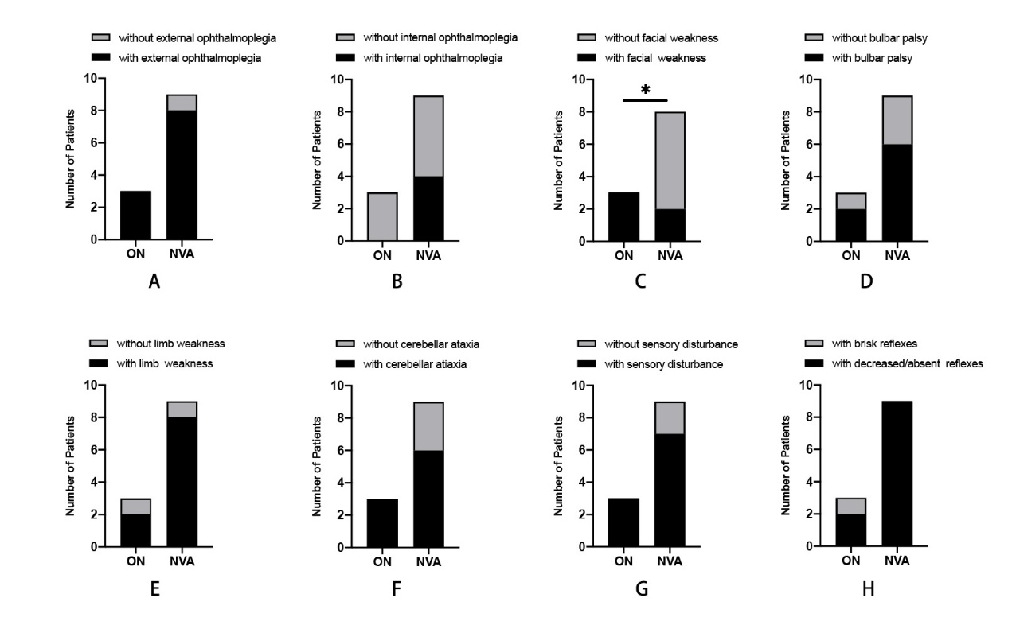
Supplementary Fig. 1. The main neurological symptoms of the ON group and the NVA group. (A–H) The presence (black bars) or absence (grey bars) of neurological symptoms occurring in the two groups, namely external ophthalmoplegia, internal ophthalmoplegia, facial weakness, bulbar palsy, limb weakness, cerebellar ataxia, sensory disturbance and brisk reflexes. Except for facial weakness, other symptoms showed no significant difference between the two groups. *p = 0.045 by Fisher’s exact test (two-tailed).

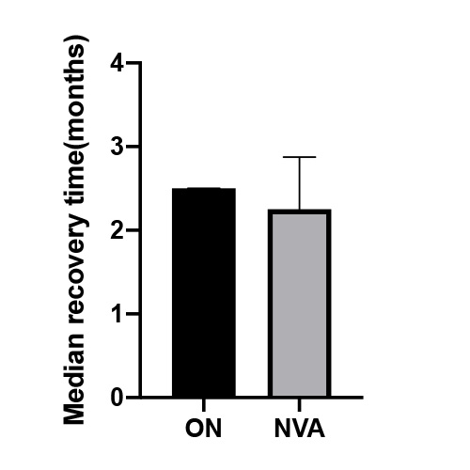
Supplementary Fig. 2. The recovery time of the ON group and the NVA group (median with interquartile range). One patient recovered at the 14th month was removed as an outlier. p > 0.10 by Wilcoxon rank sum test (2-tailed).

